Real Time Operating Systems Design and Programming
LAB 2
Thread Lab
RTOS Basics

Contents
1 Overview 2
2 Setting up RTX 2
3 RTX Thread 3
4 Thread Creation 4
5 Thread Termination 5
6 Context Switching 5
7 Lab Procedure 5

Overview
In this lab, you will configure FreeRTOS and create and destroy some threads using the CMSIS-RTOS2 API. You will walk through how the OS performs thread creation, termination and switching operations. Additionally, this lab will involve some concepts from the Scheduler Lecture - don’t worry if you do not yet understand some of the advanced features of the CMSIS-RTOS2. More specific real-time OS features and advanced embedded software development topics will be covered in later lectures and labs.

CMSIS-RTOS2 Threads
CMSIS-RTOS2 uses the word “thread” for a process. This is basically represented by a C function with the keyword “Thread” preceding the function return type. This indicates that the compiler will not handle the function entry and exit codes, which are usually responsible for managing the stack.
A typical thread looks like this:
void MyThread(void *argument) {
for (;;) {
/*…*/
}
}
Notice that a thread in an embedded system usually never terminates and should be considered as a self-contained mini program. You may start or end a thread through OS functions, which will be covered later in this lab. The return type is usually always void.

Thread Creation
Use osThreadNew():
const osThreadAttr_t MyAttr = {
.name = "GreenLedOn",
.priority = osPriorityNormal,
.stack_size = 512 // bytes
};

osThreadId_t tid = osThreadNew(MyThread, NULL, &MyAttr);
A thread can be created by other threads.

Thread Termination
Either thread-controlled:
osThreadExit(); // self‑delete (never returns)
…or externally:
osThreadTerminate(tid); // terminate another thread

Context Switching
A thread maintains mainly two sets of information: the Thread Control Block (TCB) and the thread’s private stack. The TCB is dynamically allocated when you call `osThreadNew()` (replacing the older `os_thread_create()` family). In a pre‑emptive system, every thread owns its own call stack. Its size is the `stack_size` you pass in the `osThreadAttr_t` structure and is dynamically allocated unless you supply `stack_mem` for a static stack.

Upon switching from one thread to another, the RTOS saves the CPU context. Any remaining core registers (R4‑R11 and LR) are pushed onto the current thread’s stack, and the updated process‑stack pointer (PSP) is written into that thread’s TCB. The scheduler then loads the next thread’s PSP from its TCB, pops those registers back into the CPU, and finally restores the program counter so execution continues exactly where that thread was pre‑empted.

Lab Procedure

- Start with the Template Project in "RTX Basics/Lab Template".
- If not already present, copy the main.c file provided to your project.
- Compile the code.
- Load it onto your Discovery board.
- Press the Reset button (Black joystick) on the board.
- Describe what you see from the board.
The red LED is on.
- Modify the `LED_Green_On_Thread` and `LED_Green_Off_Thread` functions to be threads. Then create one of each thread.
osThreadNew keyword and create function. See the solution project.
- Run your program on the board. Describe what you see from the board.
The red LED is on. The green LED is flashing

You should see the green LED flashing. You have created two threads, one keeps turning on the green LED and the other keeps turning it off. As they have the same priority, the scheduler will assign CPU time equally to them and preempt them as the time slice expires, resulting in the flashing. In later labs, you will understand the details of the scheduling, how to control the frequency of flashing, and how to make use of the scheduler’s features to achieve your design goal.

- Set a breakpoint at one of your “create” functions. Step through it using the F11 key to see what it does. List the major steps for creating the thread. (Note that brown text labels in the disassembly window are the names of the C functions that the following assembly code implements). List the major steps (function names) for creating the thread.
SVC_Handler → svcThreadNew → prvAllocateTCBAndStack → pxPortInitialiseStack → vListInsert → vThreadSwitchContext
prvAllocateTCBAndStack – heap allocation.
pxPortInitialiseStack – build initial context.
vListInsert – place in Ready list.
vThreadSwitchContext – dispatch f priority dictates.
You can also check the source code to get the answer. You don’t have to go into the assembly details as long as you have the general idea of what is necessary for the OS to create a thread.

- There is also a function to create a thread, where you need to pass three parameters to this function. What are the parameters and what does this function do? Make a guess first, then look up the source code to see if you are correct.
This function allows you to create a thread with specified stack and also to pass a parameter to the thread on startup: static uint64_t myStack[128/8];
const osThreadAttr_t attr = {
.name = "UsrStack",
.priority = osPriorityBelowNormal,
.stack_mem = myStack,
.stack_size = sizeof(myStack)
};

- Similarly, you can set a break point at the `osThreadExit()` line. Step through it to see what it does. List the major steps for terminating the thread.
SVC_Handler → svcThreadExit → vThreadDelete → prvDeleteTCB → PendSV
vThreadDelete marks the thread Deleted, removes it from all lists.
prvDeleteTCB checks the stack overflow and frees the stack + TCB.
PendSV schedules the next Ready thread.
So conceptually, the thread will change its states to inactive, make sure the stack and other memory is properly freed, release the mutex if it has any, unlink the TCB from lists and dispatch the next thread.
You can also check the source code to get the answer. You don’t have to go into the assembly details as long as you have the general idea of what is necessary for the OS to create a thread.

- Now try adding `osThreadYield();` to the end of both of your threads’ loops. This function tells the OS that the thread is voluntarily giving up its execution time to the next ready thread. Context switching will occur at these lines. Describe how this will affect the behaviour of the green LED. Run your program again to verify your hypothesis.
The green LED is still flashing, however, it is now much faster making it difficult to tell if the LED is constantly on. A thread will not consume all of its time slice and the OS performs the context switching immediately after the LED is turned on or off. You may need to use an oscilloscope to observe the flashing.

- Set a breakpoint at one of the `osThreadYield();` lines. Step through it to see what it does. List the major steps for context switching. Also, pay attention to the green LED while you are stepping through.

SVC_Handler → svcYield → vListRemove → vThreadSwitchContext → PendSV → restore next context

vListRemove moves the current thread back to the Ready list.

vThreadSwitchContext selects the next Ready thread of same priority.

PendSV performs a register swap.

So conceptually, the OS gets the next 'ready' thread with the same priority, puts the current thread back on the ready list, changes the state of the current thread to ‘ready’, and dispatches the next ‘ready’ thread by making its state ‘running’.

- You have been introduced to the State Transition concept in the lecture.
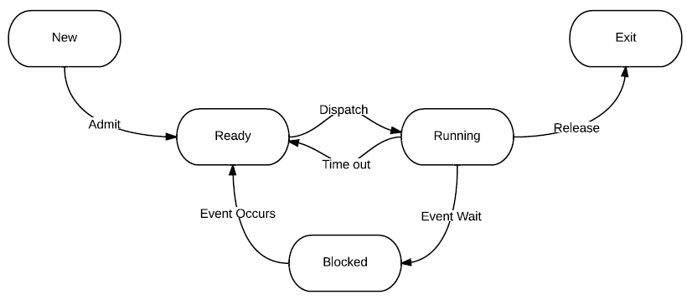
Try to match the following functions to the transitions in the State Transition model:
osThreadNew()- Admit
osThreadTerminate() / osThreadExit()- Release
osThreadYield() – Time out

